

| IT MuseUM | |
| --- | --- |
| App | |
| Final Project Plan | |
| **Academic year** | 2024/2025 |
| **Teaching Staff** | João Varajão |
| **Degree** | Master's in Telecommunications and Computer Engineering |
| **Year** | 2nd Year |
| **Curricular Unit** | Gestão de Projetos de Tecnologias de Informação |



The Team

|  | **Catarina da Cunha Malheiro da Silva Pereira**  PG53733  [pg53733@alunos.uminho.pt](mailto:pg53733@alunos.uminho.pt)  Braga, Portugal |
| --- | --- |
|  | **Inês Cabral Neves**  PG53864  [pg53864@alunos.uminho.pt](mailto:pg53864@alunos.uminho.pt)  Porto, Portugal |
|  | **Leonardo Dias Martins**  PG53996  [pg53996@alunos.uminho.pt](mailto:pg53996@alunos.uminho.pt)  Aveiro, Portugal |
|  | **Rodrigo Rocha del Castillo**  E12165  [e12165@alunos.uminho.pt](mailto:e12165@alunos.uminho.pt)  Santander, Spain |





| table of contents | **The Team 03 _________________________________ 01** |
| --- | --- |
| **Table of Contents _____________________________ 02** |
| **List of Tables ________________________________ 04** |
| **List of Figures & Graph_________________________ 05** |
| 1. **Executive Summary _____________________06** |
| 1. **Scope ________________________________07**    1. **Project Purpose ________________07**    2. **Deliverables ___________________07**    3. **Requirements __________________07**    4. **Restrictions ___________________09**    5. **Assumptions ___________________09**    6. **No Scope _____________________09** |
| **3. Stakeholders _________________________ 11**   * 1. **Stakeholders List ______________ 11**   2. **Stakeholders Matrix ____________ 11**   3. **Stakeholder Strategy ___________ 12**   4. **Time Frame ____________________ 13**   5. **Work-Package Perspective _______ 13** |
| **4. Timeline ______________________________ 14**   * 1. **List of activities ________________ 14**   2. **Gantt chart ___________________ 16**   3. **Milestones____________________ 20**   4. **Calculation of estimates _________ 20**   5. **Critical Path Management ________ 20**   6. **Description of Reserve Calculation _ 2** |
| **5. Project Costs ___________________________ 24**   * 1. **Resource List __________________ 24**   2. **Estimate Description ____________ 24**   3. **Reservation Description _________ 25**   4. **Budget _______________________ 26**      1. **Time Frame _____________ 26**      2. **Work-Package Perspective 27** |
| **6. Human Resources ______________________ 28**   1. **Basic Rules ____________________ 28** 2. **Organization Chart _____________ 28** 3. **RAM Matrix ___________________ 29** |
| **7. Quality ______________________________ 31** |
| **8. Communication Plan ____________________ 34** |
| **9. Risk _________________________________ 35**   1. **Risk List ______________________ 35** 2. **Time Perspective ________________ 35** 3. **Work-Package Perspective _______ 36** 4. **Qualitative Assessment __________ 36** 5. **Quantitative Assessment _________ 38** 6. **Risk Response Plan _____________ 39** 7. **Risk Distribution Matrix _________ 40** |
|  | **10. Hiring Plan __________________________ 41**   1. **External Services Required ______ 41** 2. **Hiring Process ________________ 41** 3. **Criteria for Selection of Proposal _ 41**    1. **Team Perspective _________ 41**    2. **Customer Perspective ______ 41** |
|  | **11. Success _____________________________ 43**   1. **Success Factors ________________ 43** 2. **Assessment Criteria _____________ 43** 3. **Success Management Process _____ 44** |
|  | **Attachments _________________________________ 45**   * 1. **Product Breakdown Structure ___________ 45**   2. **Work Breakdown Structure _____________ 46**   3. **R(e)BS ______________________________ 46**   4. **Gantt Diagram ________________________ 47** |
|  | **Declaration of Knowledge ______________________ 51** |



| **Table 1: Functional Requirements.____________________________ 08** | Table of Tables |
| --- | --- |
| **Table 2: Non-Functional Requirements. _______________________ 08** |
| **Table 3: Stakeholders Time Frame. ___________________________ 13** |
| **Table 4: Stakeholder Work - Package Perspective. ______________ 13** |
| **Table 5: List of Activities. ___________________________________ 14** |
| **Table 6: List of Activities, Start/End Date, Days, Precedence, € __ 16** |
| **Table 7 : Critical Path. ______________________________________ 20** |
| **Table 8: Time PERT Calculation.______________________________ 22** |
| **Table 9: Perspective of Budget. ______________________________ 24** |
| **Table 10: PERT Estimation. _________________________________ 25** |
| **Table 11: Budget Time Frame. _______________________________ 26** |  |
| **Table 12: RAM Matrix. ______________________________________ 29** | **Table 20: Seriousness - Scale Definition ____________________ 37** |
| **Table 13: Description of Quality Standards. ____________________ 32** | **Table 21: Probability x Impact ____________________________ 37** |
| **Table 14: Testing - Functional Requirements. __________________ 33** | **Table 22: Risks: Qualitative Assessment ____________________ 37** |
| **Table 15: Testing - Non-Functional Requirements. ______________ 33** | **Table 23: Risks: Quantitative Assessment __________________ 38** |
| **Table 16: Communication Plan. ______________________________ 34** | **Table 24: Risk Response Plan _____________________________ 39** |
| **Table 17: Risk List. _________________________________________ 35** | **Table 25: Risk Distribution Matrix __________________________ 40** |
| **Table 18: Risk - Time Perspective. ____________________________36** | **Table 26: Criteria for Evaluating Success: Team Perspective ___ 34** |
| **Table 19: Risk - Work-Package Perspective. ____________________36** | **Table 27: Criteria for Evaluating Success: Fine Customer Perspective _____________________________________________ 44** |



| Table of Figures & Graphs | **Figure 1: Stakeholder Matrix. ______________ 11** |
| --- | --- |
| **Figure 2: General Gantt Version. ____________ 16** |
| **Figure 3: Milestones. ______________________ 20** |
| **Graph 1: Time perspective. ________________ 27** |
| **Graph 2: Work-Package Perspective _________ 27** |
|  |
|  |
|  |
|  |
|  |

1. Executive Summary

This document presents the Project Charter for the IT MuseUM APP Project, requested by the museum.

The project aims to improve the experience of visiting the IT MuseUM, which is currently accompanied by museum staff and DSI department.

Therefore, the main objective of this project is to develop a mobile application that provides a more interactive and autonomous visiting experience, allowing visitors to explore the exhibitions independently and, in the end, provide their feedback directly through the application.

This work began on 19th September 2024 and ended on 10th December 2024, with a total duration of approximately 3 months and an overall budget of 6007,75 euros (€).

1. Scope
   1. **Project Purpose**

The aim of this project is to develop an application that will enrich the museum visitor's experience, offering a more interactive and personalized visit. To achieve this, it is essential to obtain feedback from visitors, which will allow the museum to better adapt to their preferences and needs.

With the aim of the project in mind, there are a number of objectives that the team is committed to fulfilling, including the following:

* Develop the application for the museum;
* Develop the necessary documentation and system architecture to make the platform more intuitive;
* Implementing the collection of visitor feedback in the application;
* Complying with the requirements negotiated with the client;
* Testing the platform.
  1. **Deliverables**

The primary goal of the deliverables is to ensure that all materials requested by the client are clearly identified and provided by the conclusion of the project. The following items will be delivered:

* **Application mockup:** A visual representation of the app’s user interface;
* **Application maintenance manual:** A technical document providing instructions for maintaining and updating the application, ensuring its long-term functionality for the client;
* **Fully functional mobile application:** The final product, a complete and working mobile app ready for deployment and use by the target audience;
* **Source Code of the application:** The source code is going to be sent to the client.
  1. **Requirements**

The Table 1 and Table 2 present the list of functional and non-functional requirements, respectively, organized by deliverables.

| Table 1: Functional Requirements. | | | | | |
| --- | --- | --- | --- | --- | --- |
| **Deliverables** | **Mockup** | **Mobile Application** | **User Manual** | **Maintenance Manual** | **Application Source Code** |
| **Functional Requirements** |
| Create room buttons / Virtual map of the museum |  | **x** |  | **x** | **x** |
| Create themed games and quizzes |  | **x** | **x** | **x** | **x** |
| Create a feedback mechanism |  | **x** | **x** | **x** | **x** |
| Allow the use of audio |  | **x** | **x** | **x** | **x** |
| Links to the museum’s website |  | **x** |  |  | **x** |



| Table 2: Non-Functional Requirements. | | | | | |
| --- | --- | --- | --- | --- | --- |
| **Deliverables** | **Mockup** | **Mobile Application** | **User Manual** | **Maintenance Manual** | **Application Source Code** |
| **Non-Functional**  **Requirements** |
| The application developed must be a mobile application | **x** | **x** |  |  | **x** |
| The system must be available whenever its use is necessary |  | **x** |  |  | **x** |
| Adequate UX-UI in order to generate a user-friendly application | **x** | **x** |  | **x** | **x** |
| The application develop must be compatible with Android systems |  | **x** |  | **x** | **x** |
| Available on Google Store and App Store |  |  |  | **x** |  |
| Quality Certificate |  | **x** |  |  |  |
| Certificate of QualityMobile application developed in App Inventor |  | **x** |  |  |  |
| Must be delivered together |  | **x** |  |  | **x** |

* 1. **Restrictions**

The existing restrictions for the project are:

* Restricted times for scheduling meetings due to differences in the working group's schedule, limiting availability to the following times: afternoons from Monday to Tuesday and full days from Friday to Sunday.
* The number of hours worked by each member of the team should not exceed 6 hours per week for the project;
* The total project budget must not be exceeded;
* The delivery date set for each deliverable must not be exceeded;
* Use of App Inventor to develop the application;
* The project must be completed by December 10, 2024;
  1. **Assumptions**

The project assumptions represent everything that has been defined in advance, together with the client, for the development of this project. The existing assumptions are as follows:

* **Dependence on content provided by the museum:** The team depends on the museum delivering content (texts, images) within agreed deadlines, which can impact the schedule if there are delays.
* **Mobile devices:** All visitors have a mobile device with which to install the application;
* **Internet access:** All museum visitors will have access to the internet (Wi-Fi or mobile data) to download and use the application.
* **Device compatibility:** Visitors' mobile devices are compatible with the application's minimum requirements with Android.
* **Operation of the technical infrastructure:** The museum will provide all the necessary resources, such as QR codes in the appropriate places, to ensure visitor interaction with the application.
* **Stakeholder availability:** The client and other stakeholders will be available to provide feedback during the development cycle.
* **Security and privacy standards:** The client agrees to follow the application's data security and privacy recommendations, such as the secure collection and storage of visitor feedback.
* **Development standards:** The team will follow previously defined development standards, such as using frameworks and programming languages compatible with the system's architecture.
  1. **No Scope**

Elements that fall outside the scope of the project are listed below:

* The project does not include the development and installation of the application on iOS and the APP STORE;
* The project does not include making the app available in the Google Store;
* The museum's app will not have login functionality;
* The project does not include a post-project technical support service.

1. Stakeholders
   1. **Stakeholder List**

The project's stakeholders include:

* **ETI students:** Directly involved and interested in the development of the project.
* **Client:** The entity that commissions the project, sets requirements, provides feedback, and ensures the final product meets their needs.
* **METI direction:** Responsible for supervising the project with the course objectives.
* **GPTI professor:** Actively involved in project management.
* **University of Minho (UM):** The institution that hosts and approves the project.
* **General public:** The users of the application and museum
* **DSI of UM:** Provision of space for the project involved in coordinating and providing technical and administrative support.
* **GPTI Group:** Catarina Pereira, Inês Neves, Leonardo Martins and Rodrigo Rocha.
* **Providers:** The Quality Certification Team evaluates whether the GPTI group's project meets the client's requirements and expectations.
  1. **Stakeholder Matrix**

The purpose of the Stakeholder Matrix, Figure 1, is to identify the different stakeholders according to their level of influence on a decision or project.

|  |
| --- |
| Figure 1: Stakeholder Matrix. |

* 1. **Stakeholder Strategy**

The stakeholders’ strategy include:

* **ETI students:** Encourage active participation through regular feedback loops, collaborative tasks and skills development opportunities. Assign roles that match their strengths and offer guidance to promote academic and technical growth. Use agile methodologies to maintain flexibility and encourage continuous learning.
* **Client:** Involve the client through structured requirements-gathering sessions, maintaining clear and open communication. Hold regular review meetings to obtain feedback and ensure alignment with the client's vision. Provide them with prototypes and project updates to manage expectations and avoid scope deviations.
* **METI direction:** Keep the METI direction updated on the project’s progress via periodic reports and presentations. Ensure the project meets the educational goals by aligning deliverables with the curriculum. Seek their guidance to resolve any academic or structural challenges.
* **GPTI professor:** Maintain regular consultation with the professor to ensure that the team follows best practices in project management. Request feedback on milestones and ensure that the professor’s expertise is leveraged for both technical and managerial challenges.
* **University of Minho (UM):** Coordinate with the university to ensure compliance with institutional policies. Keep the university’s administration informed on how the project benefits the university's objectives.
* **General public:** Conduct user research, including surveys or interviews, to understand their needs and preferences. Use this feedback to design user-friendly interfaces and features that enhance their museum experience. Plan a beta testing phase where the public can interact with the app and provide feedback for improvements.
* **DSI of UM:** Collaborate with DSI to ensure the necessary technical infrastructure is in place. Request support for software, hardware, or network needs, and make sure all administrative requirements are met, such as permissions and space allocation for development and testing.
* **GPTI Group:** Foster clear communication and collaboration within the team. Assign roles based on expertise and ensure mutual accountability. Use tools such as task management software to track progress and stay organized. Hold regular team meetings to assess progress and address any issues.
* **Providers:** The Quality Certification Team has to have clear communication, and ongoing collaboration to ensure that the application meets all required standards. By integrating their testing protocols into the project timeline and establishing a feedback loop, the team can address compliance issues throughout development. This approach ensures a seamless certification process while minimizing delays and risks.
  1. **Time Frame**

The timeline, Table 3, details stakeholder involvement over 14 weeks (September–December), covering activities like planning, development, feedback, testing, and certification.

| Table 3: Stakeholders Time Frame. | | | | | | | | | |
| --- | --- | --- | --- | --- | --- | --- | --- | --- | --- |
| **Week** | **ETI Students** | **Client** | **METI Direction** | **GPTI Professor** | **UM** | **General Public** | **DSI** | **GPTI Group** | **Providers** |
| **1** |  | **x** | **x** | **x** | **x** |  |  | **x** |  |
| **2** |  | **x** |  | **x** |  |  |  | **x** |  |
| **3** |  | **x** |  | **x** |  |  |  | **x** |  |
| **4** |  | **x** |  | **x** |  |  |  | **x** |  |
| **5** |  | **x** |  | **x** |  |  |  | **x** |  |
| **6** |  | **x** |  | **x** |  |  | **x** | **x** |  |
| **7** |  | **x** |  | **x** |  |  | **x** | **x** |  |
| **8** |  | **x** |  | **x** |  |  | **x** | **x** |  |
| **9** |  | **x** |  | **x** | **x** |  | **x** | **x** |  |
| **10** |  | **x** |  | **x** | **x** |  | **x** | **x** |  |
| **11** |  | **x** |  | **x** |  |  | **x** | **x** |  |
| **12** | **x** | **x** | **x** | **x** |  | **x** | **x** | **x** |  |
| **13** | **x** | **x** | **x** | **x** |  | **x** | **x** | **x** | **x** |
| **14** | **x** | **x** | **x** | **x** |  | **x** | **x** | **x** | **x** |

* 1. **Work-Package Perspective**

The work-package perspective, Table 4, gives the information of when the stakeholders .

| Table 4: Stakeholder Work - Package Perspective. | | | | | | | |
| --- | --- | --- | --- | --- | --- | --- | --- |
| **Work-Package** | **Initiation** | **Planning** | **Monitoring & Control** | **Implementation** | | | **Closing** |
| **Stakeholder** | **App** | **Improvement** | **Tests** |
| ETI Students |  |  |  |  |  | **x** | **x** |
| Client |  | **x** |  | **x** |  |  | **x** |
| METI Direction | **x** |  |  |  |  |  | **x** |
| GPTI Professor | **x** | **x** | **x** |  |  | **x** | **x** |
| University of Minho | **x** |  |  |  |  |  | **x** |
| General Public |  |  |  |  |  |  | **x** |
| DSI of UM | **x** |  |  |  |  |  | **x** |
| GPTI Group | **x** | **x** | **x** | **x** | **x** | **x** | **x** |
| Providers |  |  |  |  |  | **x** | **x** |

1. Timelines

## List of activities

The activities identified by the working group as being necessary and fundamental for the development of the project, Table 5.



| Table 5: List of Activities | | | | | | | |
| --- | --- | --- | --- | --- | --- | --- | --- |
| **ID** | **Name** |  | **ID** | **Name** |  | **ID** | **Name** |
| **1** | **Project Management** |  | **15** | Defining the deliverables list |  | **29** | Drawing up a schedule |
| **2** | **Initiation** |  | **16** | Drawing up the list of requirements |  | **30** | Defining milestones |
| **3** | Group Formation |  | **17** | Identifying restrictions |  | **31** | Definition of dependencies between activities |
| **4** | Meeting with the client |  | **18** | Identifying assumptions |  | **32** | Calculating reserves |
| **5** | Identification of Key Requirements |  | **19** | Preparation of WBS |  | **33** | Drawing up the critical path |
| **6** | Development of the Project Charter |  | **20** | Definition of non-scope |  | **34** | **Cost Planning** |
| **7** | Approval of the Project Charter |  | **21** | Preparation of PBS |  | **35** | Drawing up a list of resources |
| **8** | Creation of the 1st Poster |  | **22** | **Stakeholder Planning** |  | **36** | Description of cost estimates |
| **9** | 1st Poster review |  | **23** | Identifying Stakeholders |  | **37** | Definition of reservations |
| **10** | Delivery of Project Charter + 1st Poster |  | **24** | Definition of the Stakeholder matrix |  | **38** | Determining the budget |
| **11** | **Planning** |  | **25** | Drawing up a strategy for dealing with stakeholders |  | **39** | Time perspective |
| **12** | **Scope Planning** |  | **26** | Creating a work-package perspective |  | **40** | Work-package perspective |
| **13** | Framework |  | **27** | **Time Planning** |  | **41** | **Human Resources Planning** |
| **14** | Defining the purpose of the project |  | **28** | Drawing up a list of activities to be carried out |  | **42** | Developing the Organization Chart |
| **ID** | **Name** |  | **ID** | **Name** |  | **ID** | **Name** |
| **43** | Drawing up the RAM Matrix |  | **58** | Controls for identified risks |  | **76** | **Mobile App** |
| **44** | **Quality planning** |  | **59** | Develop control and monitoring reports |  | **77** | **Development of the 1st Version of the APP** |
| **45** | Drawing up quality standards |  | **60** | **Communication planning** |  | **78** | Database creation |
| **46** | Developing quality processes |  | **61** | Drawing up a Communication  Plan |  | **79** | Platform development |
| **47** | Review documentation |  | **62** | **Risk planning** |  | **80** | Quality testing |
| **48** | **Successful planning** |  | **63** | Drawing up a Risk List |  | **81** | Meeting with the client |
| **49** | Developing success factors |  | **64** | Develop a Time Perspective |  | **82** | **Final Product Development** |
| **50** | Developing success evaluation criteria |  | **65** | Work-Package perspective |  | **83** | Improvement plan |
| **51** | Develop a process to manage success |  | **66** | Drawing up a qualitative and  quantitative assessments |  | **84** | Quality testing |
| **52** | Delivery of the Simplified Project plan |  | **71** | **Execution** |  | **85** | **Finalization** |
| **53** | **Monitoring and Control** |  | **72** | Detailed identification of requirements |  | **86** | Preparation of the user manual |
| **54** | Control and monitoring of the schedule |  | **73** | **Designing Deliverables** |  | **87** | Drawing up the maintenance manual |
| **55** | Cost control and monitoring |  | **74** | Drawing up the application development plan |  | **88** | Obtaining the quality certificate |
| **56** | Control and monitoring of human resources |  | **75** | Drawing up the operating plan |  | **89** | Training session |
| **57** | Control and monitoring of project quality |  |  |  |  |  |  |



## Gantt chart

A Gantt chart, developed with ProjectLibre, manages the project schedule. Figure 2 presents a general view, with a detailed version in the Attachments.

|  |
| --- |
| Figure 2: General Gantt Version. |

The Gantt chart outlines the project's stages, tasks, milestones, and resource allocations, aiding in tracking progress and clarifying team responsibilities. The project cost exceeded the budget but stayed within the reserve, as actual hours worked (680) exceeded the planned (336), Table 6.

| Table 6: List of Activities + Start/End Date + Duration + Precedence + Costs. | | | | | | |
| --- | --- | --- | --- | --- | --- | --- |
| **ID** | **Name** | **Start Date** | **End Date** | **Precedents** | **Working Hours** | **Cost** |
| **1** | **Project Management** | **12/09/2024** | **12/12/2024** |  | **680 hours** | **6147,75€** |
| **2** | **Initiation** | **12/09/2024** | **12/10/2024** |  | **94 hours**  **40 min** | **836,90€** |
| **3** | Group Formation | 12/09/2024 | 12/09/2024 |  | 20 min | 13,71€ |
| **4** | Meeting with the client | 19/09/2024 | 19/09/2024 |  | 40 min | 27,43€ |
| **5** | Identification of Key Requirements | 19/09/2024 | 20/09/2024 | 4 | 8 hours | 68,60€ |
| **6** | Development of the Project Charter | 20/09/2024 | 27/09/2024 | 5 | 80 hours | 686,00€ |
| **7** | Approval of the Project Charter | 27/09/2024 | 27/09/2024 | 6 | 50 min | 6,86€ |
| **8** | Creation of the 1st Poster | 27/09/2024 | 28/09/2024 | 7 | 4 hours | 34,30€ |
| **9** | 1st Poster review | 28/09/2024 | 28/09/2024 | 8 | 50 min | 0,00€ |
| **10** | Delivery of Project Charter + 1st Poster | 12/10/2024 | 12/10/2024 | 7; 9 | 0 | 0,00€ |
| **11** | **Planning** | **13/10/2024** | **05/11/2024** |  | **175 hours** | **1435,03€** |
| **12** | **Scope Planning** | **13/10/2024** | **16/10/2024** |  | **60 hours** | **538,08€** |
| **13** | Framework | 13/10/2024 | 13/10/2024 | 4 | 4 hours | 34,30€ |
| **14** | Defining the purpose of the project | 13/10/2024 | 14/10/2024 | 13 | 4 hours | 40,73€ |
| **15** | Defining the deliverables list | 14/10/2024 | 14/10/2024 | 13; 14 | 4 hours | 51,45€ |
| **16** | Drawing up the list of requirements | 14/10/2024 | 14/10/2024 | 15 | 4 hours | 34,30€ |
| **17** | Identifying restrictions | 14/10/2024 | 15/10/2024 | 16 | 4 hours | 34,30€ |
| **18** | Identifying assumptions | 14/10/2024 | 14/10/2024 | 14 | 4 hours | 34,30€ |
| **19** | Preparation of WBS | 14/10/2024 | 16/10/2024 | 18 | 20 hours | 171,50€ |
| **20** | Definition of non-scope | 15/10/2024 | 15/10/2024 | 17 | 8 hours | 68,60€ |
| **21** | Preparation of PBS | 15/10/2024 | 16/10/2024 | 20 | 8 hours | 68,60€ |
| **22** | **Stakeholder Planning** | **16/10/2024** | **17/10/2024** |  | **24 hours** | **102,90€** |
| **23** | Identifying Stakeholders | 16/10/2024 | 16/10/2024 |  | 4 hours | 17,15€ |
| **24** | Definition of the Stakeholder matrix | 16/10/2024 | 16/10/2024 | 23 | 4 hours | 17,15€ |
| **25** | Drawing up a strategy for dealing with stakeholders | 16/10/2024 | 17/10/2024 | 23 | 8 hours | 34,30€ |
| **26** | Creating a work-package perspective | 16/10/2024 | 16/10/2024 |  | 8 hours | 34,30€ |
| **27** | **Time Planning** | **18/10/2024** | **21/10/2024** | **22** | **32 hours** | **343,00€** |
| **28** | Drawing up a list of activities to be carried out | 18/10/2024 | 18/10/2024 | 25; 26 | 4 hours | 34,30€ |
| **29** | Drawing up a schedule | 18/10/2024 | 18/10/2024 | 21; 26 | 4 hours | 34,30€ |
| **30** | Defining milestones | 18/10/2024 | 19/10/2024 | 29 | 4 hours | 34,30€ |
| **31** | Definition of dependencies between activities | 18/10/2024 | 19/10/2024 | 29 | 4 hours | 34,30€ |
| **32** | Calculating reserves | 19/10/2024 | 19/10/2024 | 31 | 8 hours | 68,8€ |
| **33** | Drawing up the critical path | 19/10/2024 | 21/10/2024 | 32 | 8 hours | 137,20€ |
| **34** | **Cost Planning** | **22/10/2024** | **24/10/2024** | **27** | **23 hours** | **197,23€** |
| **35** | Drawing up a list of resources | 22/10/2024 | 22/10/2024 | 28 | 2 hours | 17,15€ |
| **36** | Description of cost estimates | 22/10/2024 | 22/10/2024 | 20 | 2 hours | 17,15€ |
| **37** | Definition of reservations | 22/10/2024 | 22/10/2024 | 36 | 3 hours | 25,73€ |
| **38** | Determining the budget | 22/10/2024 | 24/10/2024 | 33; 37 | 12 hours | 102,90€ |
| **39** | Time perspective | 22/10/2024 | 22/10/2024 | 23 | 2 hours | 17,15€ |
| **40** | Work-package perspective | 22/10/2024 | 22/10/2024 | 39 | 2 hours | 17,15€ |
| **41** | **Human Resources Planning** | **24/10/2024** | **24/10/2024** |  | **4 hours** | **13,72€** |
| **42** | Developing the Organization Chart | 24/10/2024 | 24/10/2024 |  | 2 hours | 6,86€ |
| **43** | Drawing up the RAM Matrix | 24/10/2024 | 24/10/2024 | 42 | 2 hours | 6,86€ |
| **44** | **Quality planning** | **04/11/2024** | **05/10/2024** |  | **20 hours** | **137,20€** |
| **45** | Drawing up quality standards | 04/11/2024 | 04/11/2024 |  | 4 hours | 27,44€ |
| **46** | Developing quality processes | 04/11/2024 | 05/11/2024 | 45 | 8 hours | 54,88€ |
| **47** | Review documentation | 05/11/2024 | 05/11/2024 | 44;45 | 8 hours | 54,88€ |
| **48** | **Successful planning** | **13/10/2024** | **14/10/2024** |  | **12 hours** | **102,90€** |
| **49** | Developing success factors | 13/10/2024 | 13/10/2024 |  | 4 hours | 34,30€ |
| **50** | Developing success evaluation criteria | 13/10/2024 | 14/10/2024 | 49 | 4 hours | 34,30€ |
| **51** | Develop a process to manage success | 14/10/2024 | 14/10/2024 | 50 | 4 hours | 34,30€ |
| **52** | Delivery of the Simplified Project plan | 02/11/2024 | 02/11/2024 |  | 0 hours | 0,00€ |
| **53** | **Monitoring and Control** | **02/11/2024** | **19/11/2024** |  | **50 hours** | **354,50€** |
| **54** | Control and monitoring of the schedule | 19/11/2024 | 19/11/2024 | 60 | 8 hours | 137,20€ |
| **55** | Cost control and monitoring | 02/11/2024 | 02/11/2024 | 34 | 4 hours | 68,60€ |
| **56** | Control and monitoring of human resources | 02/11/2024 | 03/11/2024 | 55 | 8 hours | 137,20€ |
| **57** | Control and monitoring of project quality | 02/11/2024 | 03/11/2024 |  | 8 hours | 68,60€ |
| **58** | Controls for identified risks | 02/11/2024 | 02/11/2024 |  | 4 hours | 68,60€ |
| **59** | Develop control and monitoring reports | 02/11/2024 | 02/11/2024 | 34 | 2 hours | 34,30€ |
| **60** | **Communication planning** | **04/11/2024** | **03/11/2024** |  | **2 hours** | **20,00€** |
| **61** | Drawing up a Communication  Plan | 04/11/2024 | 04/11/2024 |  | 2 hours | 20,00€ |
| **62** | **Risk planning** | **04/11/2024** | **06/11/2024** | **60** | **12 hours** | **120,00€** |
| **63** | Drawing up a Risk List | 04/11/2024 | 04/11/2024 |  | 2 hours | 20,00€ |
| **64** | Develop a Time Perspective | 04/11/2024 | 04/11/2024 |  | 2 hours | 20,00€ |
| **65** | Work-Package perspective | 05/11/2024 | 05/11/2024 |  | 2 hours | 20,00€ |
| **66** | Drawing up a qualitative and  quantitative assessments | 05/11/2024 | 05/11/2024 |  | 2 hours | 20,00€ |
| **67** | Building a risk distribution  matrix | 05/11/2024 | 06/11/2024 |  | 2 hours | 20,00€ |
| **68** | Develop a risk response plan | 06/11/2024 | 06/11/2024 |  | 2 hours | 20,00€ |
| **69** | **Hiring Plan** | **20/11/2024** | **20/11/2024** |  | **2 hours** | **20,00€** |
| **70** | Develop contracting plan | 20/11/2024 | 20/11/2024 |  | 2 hours | 20,00€ |
| **71** | **Execution** | **04/11/2024** | **03/12/2024** |  | **329 hours** | **2820,59€** |
| **72** | Detailed identification of requirements | 04/11/2024 | 04/11/2024 |  | 2 hours | 17,15€ |
| **73** | **Designing Deliverables** | **04/11/2024** | **04/11/2024** |  | **4 hours** | **68,60€** |
| **74** | Drawing up the application development plan | 04/11/2024 | 04/11/2024 |  | 2 hours | 34,30€ |
| **75** | Drawing up the operating plan | 04/11/2024 | 04/11/2024 | 63 | 2 hours | 34,30€ |
| **76** | **Mobile App** | **15/11/2024** | **04/12/2024** | **62** | **157 hours** | **2734,84€** |
| **77** | **Development of the 1st Version of the APP** | **15/11/2024** | **28/11/2024** |  | **135 hours** | **2357,84€** |
| **78** | Database creation | 15/11/2024 | 19/11/2024 |  | 40 hours | 686,00€ |
| **79** | Platform development | 19/11/2024 | 26/11/2024 | 67 | 71 hours | 1225,64€ |
| **80** | Quality testing | 26/11/2024 | 28/11/2024 | 67;68 | 22 hours | 377,30€ |
| **81** | Meeting with the client | 28/11/2024 | 28/11/2024 | 69 | 2 hours | 68,60€ |
| **82** | **Final Product Development** | **02/12/2024** | **04/11/2024** | **70** | **22 hours** | **377,30€** |
| **83** | Improvement plan | 02/12/2024 | 02/12/2024 |  | 8 hours | 137,20€ |
| **84** | Quality testing | 02/12/2024 | 04/12/2024 | 72 | 14 hours | 240,10€ |
| **85** | **Finalization** | **06/12/2024** | **12/12/2024** | **60** | **15 hours**  **20 min** | **379,54€** |
| **86** | Preparation of the user manual | 06/12/2024 | 06/12/2024 |  | 4 hours | 68,60€ |
| **87** | Drawing up the maintenance manual | 06/12/2024 | 06/12/2024 | 73 | 4 hours | 68,60€ |
| **88** | Obtaining the quality certificate | 06/12/2024 | 06/12/2024 |  | 5 hours | 160,00€ |
| **89** | Training session | 07/12/2024 | 07/12/2024 | 77 | 2 hours | 68,60€ |
| **90** | Delivery of deliverables to the client | 09/12/2024 | 09/12/2024 |  | 0 min | 0,00€ |
| **91** | Delivery of the final report | 09/12/2024 | 09/12/2024 |  | 0 min | 0,00€ |
| **92** | Final presentation | 12/12/2024 | 12/12/2024 | 80 | 20 min | 13,71€ |

## Milestones

The Figure 3 highlights all the deliverable dates committed by the team. Internal milestones, corresponding to course-related deliverables, are shown at the bottom, while external milestones, associated with client-specific project deliverables, are displayed at the top. Notably, the client will have access to all documents submitted by the team within the course context.

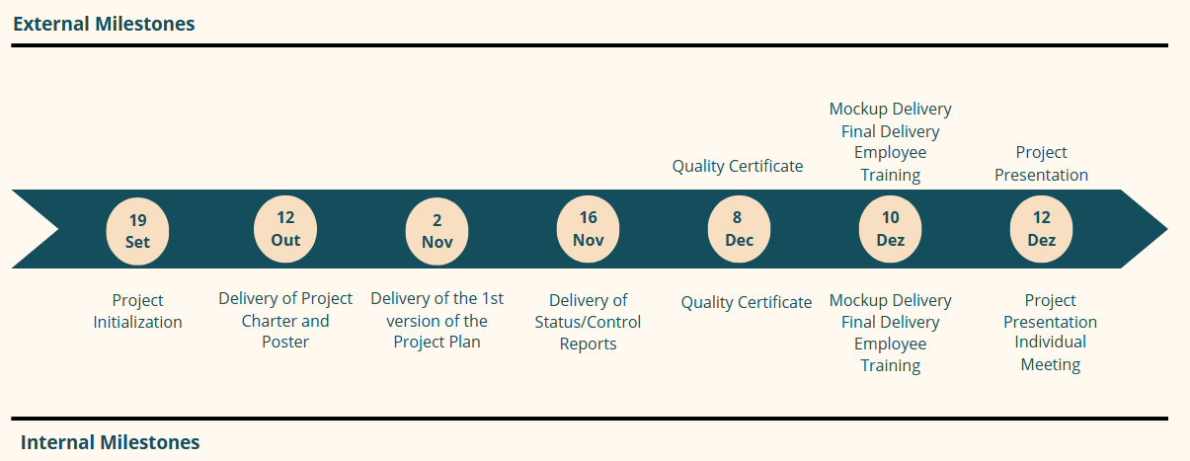

| Figure 3: Milestones. |
| --- |

## Calculation of Estimates

Task estimates were based on the team's experience and understanding of individual capabilities, leveraging insights from previous collaborations. This approach considered time constraints, deliverable schedules, and the overall deadline. Detailed task planning is outlined in Section 4.B.

## Critical Path Management

The critical path, Table 7, is a set of tasks that are linked and directly affect the project's completion date. If any of these tasks is behind schedule, the whole project is behind schedule.

| Table 7 : Critical Path. | | |
| --- | --- | --- |
| **WBS** | **Activity** | **Duration** |
| **1.1** | **Initiation** |  |
| 1.1.3 | Identification of Key Requirements | 8 hours |
| 1.1.4 | Development of the Project Charter | 40 hours |
| 1.1.5 | Creation of the poster | 4 hours |
| **1.2** | **Planning** |  |
| **1.2.1** | **Scope Planning** |  |
| 1.2.1.1 | Framework | 4 hours |
| 1.2.1.2 | Defining the purpose of the project | 4 hours |
| 1.2.1.4 | Defining the deliverables list | 4 hours |
| **1.2.3** | **Time Planning** |  |
| 1.2.3.1 | Drawing up a list of activities to be carried out | 4 hours |
| 1.2.3.2 | Drawing up a schedule | 4 hours |
| 1.2.3.6 | Drawing up the critical path | 8 hours |
| **1.2.4** | **Cost Planning** |  |
| 1.2.4.4 | Determining the budget | 12 hours |
| **1.2.3** | **Human Resources Planning** |  |
| 1.2.3.1 | Drawing up a list of activities to be carried out | 4 hours |
| 1.2.3.2 | Drawing up a schedule | 4 hours |
| **1.2.6** | **Quality planning** |  |
| 1.2.6.3 | Review documentation | 8 hours |
| **1.2.7** | **Successful planning** |  |
| 1.2.7.1 | Developing success factors | 4 hours |
| 1.2.7.2 | Developing success evaluation criteria | 4 hours |
| 1.2.7.3 | Develop a process to manage success | 4 hours |
| **1.4** | **Execution** |  |
| **1.4.2** | **Mobile App** |  |
| **1.4.2.1** | **Development of the 1st Version of the APP** |  |
| 1.4.2.1.1 | Database creation | 40 hours |
| 1.4.2.1.2 | Platform development | 71 hours |
| 1.4.2.1.3 | Quality testing | 22 hours |
| **1.4.2.2** | **Final Product Development** |  |
| 1.4.2.2.1 | Improvement plan | 8 hours |
| **1.5** | **Finalization** |  |
| 1.5.1 | Preparation of the user manual | 4 hours |
| 1.5.2 | Drawing up the maintenance manual | 4 hours |
| 1.5.3 | Obtaining the quality certificate | 5 hours |
| 1.5.7 | Final presentation | 15 min |

## 

## Description of Reserve Calculation

The Critical Chain Method identified reserves for critical path activities, calculated using the PERT method, Table 8.

| Table 8: Time PERT Calculation. | | | | | |
| --- | --- | --- | --- | --- | --- |
| **Activity** | **Estimate** | | | **PERT** | **Reserve** |
| **Optimistic** | **Probable** | **Pessimistic** |
| **Initiation** |  |  |  |  |  |
| Identification of Key Requirements | 4 | 8 | 16 | 8,(6) | 0,(6) |
| Development of the Project Charter | 20 | 40 | 80 | 43,(3) | 3,(3) |
| Creation of the poster | 2 | 4 | 8 | 4,(3) | 0,(3) |
| **Planning** |  |  |  |  |  |
| **Scope Planning** |  |  |  |  |  |
| Framework | 2 | 4 | 8 | 4,(3) | 0,(3) |
| Defining the purpose of the project | 2 | 4 | 8 | 4,(3) | 0,(3) |
| Defining the deliverables list | 2 | 4 | 8 | 4,(3) | 0,(3) |
| **Time Planning** |  |  |  |  |  |
| Drawing up a list of activities to be carried out | 2 | 4 | 8 | 4,(3) | 0,(3) |
| Drawing up a schedule | 2 | 4 | 8 | 4,(3) | 0,(3) |
| Drawing up the critical path | 2 | 8 | 16 | 8,(3) | 0,(3) |
| **Cost Planning** |  |  |  |  |  |
| Determining the budget | 8 | 12 | 24 | 13,(3) | 1,(3) |
| **Human Resources Planning** |  |  |  |  |  |
| Drawing up a list of activities to be carried out | 2 | 4,00 | 10 | 4,(6) | 0,(6) |
| Drawing up a schedule | 2 | 4,00 | 16 | 5,(6) | 1,(6) |
| **Quality planning** |  |  |  |  |  |
| Review documentation | 4 | 8,00 | 40 | 12,(6) | 4,(6) |
| **Successful planning** |  |  |  |  |  |
| Developing success factors | 2 | 4,00 | 10 | 4,(6) | 0,(6) |
| Developing success evaluation criteria | 2 | 4,00 | 10 | 4,(6) | 0,(6) |
| Develop a process to manage success | 2 | 4,00 | 10 | 4,(6) | 0,(6) |
| **Execution** |  |  |  |  |  |
| **Mobile App** |  |  |  |  |  |
| **Development of the 1st Version of the APP** |  |  |  |  |  |
| Database creation | 20 | 40,00 | 70 | 41,(6) | 1,(6) |
| Platform development | 60 | 71,00 | 100 | 74 | 3 |
| Quality testing | 11 | 22,00 | 50 | 24,8(3) | 2,8(3) |
| **Final Product Development** |  |  |  |  |  |
| Improvement plan | 4 | 8,00 | 30 | 11 | 3 |
| **Finalization** |  |  |  |  |  |
| Preparation of the user manual | 2 | 4,00 | 10 | 4,(6) | 0,(6) |
| Drawing up the maintenance manual | 2 | 4,00 | 10 | 4,(6) | 0,(6) |
| Obtaining the quality certificate | 30 | 40,00 | 60 | 41,(6) | 1,(6) |
| Final presentation | 0,25 | 0,(25) | 0,56(3) | 0,35(7) | 0,02(4) |
| **Total** | **189,1(6)** | **309,25** | **610,56(3)** | **339,455** | **30,205)** |

Based on Table 8, the anticipated total work hours for this project amount to approximately **339 hours and 30 minutes**.

1. Project Costs
2. **Resource List**

This resource list in Table 9 provides a budget breakdown for the project.

|  | Table 9: Perspective of Budget. | | | |
| --- | --- | --- | --- | --- |
| **Description** | | **Details** | **Justification** | **Price** |
| Member Salary | | 4 members at 10€/hour, working 6 hours/week for 14 weeks. | Compensation for the team involved in developing the project. | 3 51,00 € |
| Traveling | | Weekly travel for 14 weeks (169.2 km, €34.18/day). | Necessary for client meetings and stakeholder engagement. | 478,52 € |
| Equipment | | 4 computers | Essential tools for project work and communication. | 269,23 € |
| Meeting Room | | Rent for a conference room with projector and internet. | Necessary for team meetings and presentations with stakeholders. | 600,00 € |
| Quality Certificate | | Safety and performance audits. | To ensure compliance with technical requirements at the end of the project. | 120,00 € |
| Marketing costs | | Promotional materials | Leaflets, posters and digital marketing | 800,00 € |
| **Total** | | | | **5777,75 €** |

1. **Estimate Description**

This budget ensures that all critical areas, including travel, equipment, team compensation, and marketing, are accounted for, providing a clear and structured financial framework for the project.

* **Human Resources:**
  + **Team Salary:** The team is composed of four members, each earning €10/hour. With each member working 6 hours per week for a 14-week project duration, the total salary cost per person is €840. The team worked more hours then supposed too.
  + **Travel Costs:** The cost of each weekly trip for two team members is €34.18, which includes tolls (€3.50/day) and fuel with the help of “ViaMichelin”.
* **Equipment Costs:** Each team member uses a computer with an average cost of 1000€. To determine the value of a 4-year-old computer for this 14-week project, the straight-line depreciation method is applied, distributing the cost over the equipment's estimated 4-5 year lifespan. The remaining value is then prorated for the duration of the project.
  + Estimated useful life: 4 years.
  + Annual depreciation: 1000€ / 4 = 250€.
  + Depreciated value after 3 years: 1000€ - (3 x 250€) = 250€.
  + Weekly depreciation cost: 250€ / 52 weeks = 4.81€/week.
* **Meeting Room Rental:** The team will rent a conference room in Guimarães, which is equipped with the necessary facilities for effective project communication and client engagement. The room rental cost is €600 for the entire project duration.
* **Quality Certification:** To ensure that the project complies with safety and technical standards, a Quality Certificate audit will be conducted at the end of the project. This will cost €500.
* **Marketing Costs:** A marketing campaign will be launched at the project’s completion, including both print materials (leaflets, posters) and digital marketing efforts, with a total cost of €800.

1. **Reservation Description**

The value of the reservation is calculated by the PERT estimative, Table 10 (profit margins and IVA are not accounted for).

For the pessimistic estimate, the team assumed each member would work 10 hours per week, an additional 4 hours beyond the typical workload, totaling the time required to complete the project. This estimate also factored in 16 trips with a longer journey cost of €0.21 per kilometer, and the need for five computers.

In the optimistic scenario, assuming everything goes better than planned, the cost of human resources was reduced based on a decrease in weekly working hours to 4 hours, covering both execution and management. For travel, the variation factor included different routes at a lower cost of €0.18 per kilometer, while the equipment needs were adjusted to require only three computers.

| Table 10: PERT Estimation. | | | | | |
| --- | --- | --- | --- | --- | --- |
| **Description** | **Optimistic Cost** | **Probable cost** | **Pessimistic cost** | **PERT** | **Reservation** |
| Member Salary | 2 240,000 € | 3 510,000 € | 5 120,000 € | 3 566,667 € | 56,667 € |
| Traveling | 402,640 € | 478,520 € | 532,560 € | 474,880 € | 3,640 € |
| Equipment | 201,923 € | 269,231 € | 336,538 € | 269,231 € | 0,000 € |
| Room | 140,000 € | 600,000 € | 3 400,000 € | 990,000 € | 390,000 € |
| Quality Certificate | 100,000 € | 120,000 € | 500,000 € | 533,333 € | 60,00 € |
| Marketing Costs | 150,000 € | 800,000 € | 1 500,000 € | 808,333 € | 8,333 € |
| **Total** | **3 234,563 €** | **5 777,751 €** | **11 389,098 €** | **6 215,777 €** | **518,64 €** |

It should be emphasized that the figures for salaries, travel and equipment are subject to IVA at the rate in vigor.

1. **Budget**

Considering the estimated project costs along with the calculated reserves (as shown in Table 3), the total budget for this project amounts to €6296,40.

* 1. **Time Frame**

The budget timeline is outlined in Table 11. The Quality Certificate and Marketing Costs are scheduled for the final week of the project, as the Quality Certificate will assess the project's outcome, and the marketing campaign will be launched upon project completion.

| Table 11: Budget Time Frame. | | | | | | | |
| --- | --- | --- | --- | --- | --- | --- | --- |
| **Week** | **Human Resources** | **Equipment** | **Meeting Room** | **Quality Certificate** | **Marketing Costs** | **Reserves Costs** | **Total** |
| 1 | 274,18 € | 19,23 € | 42,86 € |  |  | 40,62 € | **376,89 €** |
| 2 | 274,18 € | 19,23 € | 42,86 € |  |  | 40,62 € | **376,89 €** |
| 3 | 274,18 € | 19,23 € | 42,86 € |  |  | 40,62 € | **376,89 €** |
| 4 | 274,18 € | 19,23 € | 42,86 € |  |  | 40,62 € | **376,89 €** |
| 5 | 274,18 € | 19,23 € | 42,86 € |  |  | 40,62 € | **376,89 €** |
| 6 | 274,18 € | 19,23 € | 42,86 € |  |  | 40,62 € | **376,89 €** |
| 7 | 274,18 € | 19,23 € | 42,86 € |  |  | 40,62 € | **376,89 €** |
| 8 | 274,18 € | 19,23 € | 42,86 € |  |  | 40,62 € | **376,89 €** |
| 9 | 274,18 € | 19,23 € | 42,86 € |  |  | 40,62 € | **376,89 €** |
| 10 | 274,18 € | 19,23 € | 42,86 € |  |  | 40,62 € | **376,89 €** |
| 11 | 274,18 € | 19,23 € | 42,86 € |  |  | 40,62 € | **376,89 €** |
| 12 | 274,18 € | 19,23 € | 42,86 € |  |  | 40,62 € | **376,89 €** |
| 13 | 274,18 € | 19,23 € | 42,86 € | 120 € | 400 € | 40,62 € | **896,89 €** |
| 14 | 274,18 € | 19,23 € | 42,86 € |  | 400 € | 40,62 € | **776,89 €** |
| **Total** | **3 360,00 €** | **269,23 €** | **600,00 €** | **120,00 €** | **800,00 €** | **541,97** | **6 296,40 €** |

The Time Perspective (Graph 1) shows the distribution of the project budget over the various weeks defined for its development.

| Graph 1: Time perspective. |
| --- |
| Points scored |

* 1. **Work-Package Perspective**

| Graph 2: Work-Package Perspective. |
| --- |
| Points scored |

1. Human Resources

In this chapter, Human Resources Planning, the following points will be presented: Basic Rules, Organisation Chart and RAM Matrix.

1. **Basic Rules**

To ensure the smooth running and success of the project, the team must respect and comply with the following rules:

* **Attendance & Justification:** If any member of the team is unable to attend a meeting, they must justify their absence and show an interest in finding out about the decisions taken during the meeting.
* **Responsibility for tasks:** Each team member is responsible for the tasks assigned to them and must undertake to fulfil them within the deadlines set.
* **Equal responsibilities:** There are no specific positions assigned. All members share the same responsibilities and have an equal role in the success of the project.
* **Weekly Meetings:** The team undertakes to hold weekly meetings to control and monitor the progress of the project and adjust the work plan if necessary. The meetings will be held on the Zoom platform.
* **External communication:** The group leader will be responsible for communicating with the course lecturer and the clients (final and project) whenever meetings need to be scheduled or held.
* **Recognising Positive Performance:** If any member of the team stands out positively during the course of the project, they will be rewarded with a higher mark than the rest of their colleagues.
* **Negative Performance Penalty:** If any member of the team underperforms, they will be penalised with a lower score than the rest of the team.
* **Remuneration**: Each member of the team will be paid €10/hour for their work.

These rules aim to ensure a fair, productive and collaborative working environment, promoting the fulfilment of project objectives and guaranteeing the satisfaction of all parties involved.

1. **Organization Chart**

The organisational chart of all those involved in this project is shown on Graph X. This diagram shows the hierarchy within the project team as well as the main positions.

| Graph : Organizational chart. |
| --- |
|  |

1. **RAM Matrix**

The Responsibility Matrix (RAM), Table 12, allows roles and responsibilities to be assigned within a project. A table was therefore developed that cross-references the tasks resulting from the Gantt chart with the team members based on the following responsibilities:

* S: Responsible for carrying out the task
* A: Approves and guarantees the execution of the task
* I: Informed of the decision
* C: Must be consulted

| Table 12: RAM Matrix. | | | | |
| --- | --- | --- | --- | --- |
| **Work Team** | **Catarina Pereira** | **Inês Neves** | **Leonardo Martins** | **Rodrigo Castillo** |
| **Tasks** |
| **Initiation** | **S** | **S** | **S** | **S** |
| **Planning** | **S** | **S** | **S** | **S** |
| **Scope Planning** | **S** | **S** |  |  |
| **Stakeholder Planning** | **S** |  |  |  |
| **Time Planning** | **S** |  |  |  |
| **Cost Planning** | **S** |  |  |  |
| **Human Resources Planning** | **S** | **S** |  |  |
| **Quality Planning** | **S** | **S** |  |  |
| **Successful Planning** | **S** | **S** |  |  |
| **Monitoring and Control** | **S** | **S** | **S** | **S** |
| **Risk Planning** | **A** | **I** | **I** | **I** |
| **Communication Planning** |  | **S** |  |  |
| **Risk Planning** |  | **S** |  |  |
| **Hiring Planning** |  | **S** |  |  |
| **Execution** | **S** | **S** | **S** | **S** |
| **Designing Deliverables** | **S** |  |  |  |
| **Mobile APP** | **A** | **I** | **S** | **S** |
| **Development of the 1st Version of the APP** |  |  | **S** |  |
| **Final Product Development** |  |  | **S** |  |
| **Finalization** | **S** | **S** | **S** | **S** |

7. Quality

Internationally recognised standards and good practices were adopted in the execution of this project:

* **Project Management:** For project management, the guidelines of **ISO Standard 21500** and the **PMBOK (Project Management Body of Knowledge)** were followed, guaranteeing a structured, efficient approach in line with global standards.
* **Product Quality:** With regard to product quality, **ISO Standard 25010** was applied, which defines reference quality models, identifying the characteristics that should be considered when evaluating the product developed.
* **Quality Planning:** Within the scope of **Quality Planning,** the following will be presented: **Quality Standards, Quality Assurance Processes and Quality Control.**.

This systematic approach ensures that both the management process and the final product meet the highest quality standards, promoting the satisfaction of all stakeholders.

## Quality standards

In order to ensure that the solution developed by the team follows proven and recognised quality standards, the **ISO/IEC 25010 Standard** defines a quality model made up of the following characteristics:

* **Functional Adequacy:** Ability of the product to provide functions that fulfil the explicit and implicit needs of users in the defined context.
* **Performance Efficiency:** Efficiency of the product in relation to the resources used under the specified conditions.
* **Compatibility:** The product's ability to share information and work together with other systems in the same hardware or software environment.
* **Usability:** The ease with which users can achieve their specific objectives effectively, efficiently and satisfactorily.
* **Reliability:** The product's ability to perform specific functions consistently over a given period of time.
* **Security:** Protection of the product's information and data, guaranteeing appropriate access based on defined authorisation levels.
* **Maintainability:** The ease with which the product can be modified for improvements, corrections or adaptations to new requirements or conditions.
* **Portability:** The product's ability to be transferred from one environment to another effectively and efficiently.

These features ensure that the final solution meets high quality standards, in line with user needs and industry best practices, Table 13.

| Table 13: Description of Quality Standards. | | | | |
| --- | --- | --- | --- | --- |
| **Features** | **Sub-category** |  | **Features** | **Sub-category** |
| **Functional Adequacy** | Functional adjustment |  | **Reliability** | Maturity |
| Functional Correctness |  | Availability |
| Functional Integrity |  | Recoverability |
| **Performance Efficiency** | Response Time |  | Fault tolerance |
| Resource Utilisation |  | **Security** | Integrity |
| Capacity |  | Authenticity |
| **Compatibility** | Interoperability |  | Accountability |
| **Usability** | Suitability |  | Non-repudiation |
| Protection for user errors |  | Confidentiality |
| Aesthetics |  | **Maintainability** | Testability |
| Operability |  | Modifiability |
| Learnability |  | Modularity |
| Ease of use |  | Reusability |
| **Portability** | Adaptability |  | Analysability |
| Stability |  |  |  |
| Substitutability |  |  |  |

## Processes for quality assurance and control

In order to ensure that the solution developed by the team meets the expected levels of quality that the client expects, it was necessary to carry out some tests on its operation. To this end, the team will run all the functionalities of the platform developed, both at front-end and back-office level, in order to identify possible flaws in its use. The tests in question are intended to take into account the different types of users of the platform.

### i. Functional Requirements

These tests aim to validate that the platform operates as intended and meets user requirements, Table 14.

| Table 14: Testing - Functional Requirements. | | | |
| --- | --- | --- | --- |
| **System Area** | **Page** | **Test to perform** | **Expected Result** |
| Navigation | Introduction Page | Verify the introduction page loads correctly and displays the "Começar a explorar" button. | The button should redirect to the main page without errors. |
| Navigation | Main Page | Test navigation to the main page after clicking "Começar a explorar" |  |
| Information Display | Room Selection | Ensure each room icon is clickable and provides detailed information about the room. | The information for each room must be displayed correctly when you click. |
| Map Integration | Map Page | Verify the interactive map displays all rooms and supports proper zoom and pan functionality. | The map must load correctly and allow user interaction. |
| QR Code Scanner | QR Code Reader | Test QR code scanning functionality for accurate recognition and redirection to the corresponding room. | The QR Code must be interpreted correctly and redirect to the associated information. |
| Feedback | Feedback Form | Ensure the feedback form works properly, collects inputs, and submits data successfully. | Feedback must be sent and stored successfully. |
| Quiz | Quiz Page | Test the functionality of the quiz, including checking the answers and giving feedback to the user. | The quiz must record answers, provide feedback and display the final score correctly. |

### ii. Non-Functional Requirements

These tests ensure the platform performs well under specified conditions and delivers a quality user experience, Table 15.

| Table 15: Testing - Functional Requirements. | |
| --- | --- |
| **Test Type** | **Description** |
| Usability Test | Put a user unfamiliar with the system to navigate the platform and measure ease of use and task completion. |
| Performance Test | Assess response time, resource usage, and performance under varying conditions. |
| Compatibility Test | Validate functionality across different mobile devices and operating systems. |
| Reliability Test | Ensure the platform consistently performs expected functions over an extended period. |

8. Communication Plan

The Communication Plan was created with the Quality Certificate Team, Table 16.

|  | Table 16: Communication Plan. | | | |
| --- | --- | --- | --- | --- |
| **Communication Channel**  **(Who?)** | **Information**  **(What?)** | **Objective (Why?)** | **Frequency**  **(How often?)** | **Medium**  **(How?)** |
| **Client** | Project follow-up meeting | Meetings to monitor & evaluate project performance in order to meet the client's expectations & obtain feedback from the client | Seasonal | In person |
| Information Exchange | Doubts that may exist on the part of both the work team and the client regarding the development of the project. | Seasonal | In person |
| **Sponsor**  **(GPTI Lecturer)** | Weekly Meetings | Meetings held to monitor and control the work carried out | Weekly | In person |
| Deliverables | Delivery of the various deliverables established at the beginning of the semester | Punctual (with pre-defined milestones) | In person |
| Questions & Project Feedback | Questions that the team may have during the development of the project, as well as feedback from stakeholders on the work carried out. | Seasonal | In person |
| **Quality certification team** | Quality Certificate | Discussion of budget and quality criteria with the aim of obtaining quality certification | 2 times | Via Discord |
| **Work Team** | Project meetings | Distributing tasks and providing feedback on the current state of the project | Daily | Via WhatsApp or Zoom |
| Document Sharing | Platform for the team to make the documents produced available | Daily | Via Google Drive |
| Discussion of ideas | Discuss new ideas, corrections to improve the project | Weekly | Via WhatsApp or Zoom |
| Project Management | Manage project tasks in the best way to ensure that the work is carried out as planned | Daily | Via WhatsApp |

9. Risk

1. **Risk List**

Effective risk analysis is vital for project development, enabling proactive management of potential issues. Risks are assessed for likelihood, impact, and seriousness (calculated as probability × impact), using a 1-to-5 scale, Table 17. Mitigation actions are outlined to minimize impacts, with focus on high-seriousness risks to keep the project on track.

| Table 17: Risk List. | | | |
| --- | --- | --- | --- |
| **ID** | **Description** | **Mitigation Plan** | **Potential Impact** |
| **1** | **Loss of a team member** | Ensure clear communication, strong team organization, and ongoing motivation | Overload of working hours by other team members |
| **2** | **Loss of customer confidence** | Maintain regular communication with the client, keeping them informed | Risk of project misalignment or failure |
| **3** | **Exceeding the stipulated budget** | Continuously assess time allocations for each task to control costs | Potential failure in project management review |
| **4** | **Delays in milestone / deliverable delivery** | Monitor and control deadlines set in the Gantt chart for all activities | Delays could affect project final grade |
| **5** | **Misinterpretation of customer requirements** | Customer dissatisfaction due to unmet application requirements. | Constant monitoring of the client through meetings. |
| **6** | **Lack of technical skills in the team** | Delay in the development of tasks related to the execution of the project | Use tools such as YouTube and supporting documentation to improve the skills required. |
| **7** | **Failure to fulfil project tasks** | Delay in the development of other project activities | Holding weekly meetings to monitor and control the development of tasks |
| **8** | **Poor communication among team members** | Delay in completing project tasks | Communication plan defining strategies and platforms to be used |
| **9** | **Lack of business knowledge** | Hours wasted on redesigning application mock-ups | Meet several times with the client to better understand the business |
| **10** | **Hardware and software problems** | Development of the application and project documentation will be severely delayed | Carry out equipment maintenance, as well as weekly backups |

1. **Time Perspective**

Table 18 shows the risks associated with each working week.

| Table 18: Risk - Time Perspective. | | | | | | | | | | | | | | |
| --- | --- | --- | --- | --- | --- | --- | --- | --- | --- | --- | --- | --- | --- | --- |
| **Week** | **1** | **2** | **3** | **4** | **5** | **6** | **7** | **8** | **9** | **10** | **11** | **12** | **13** | **14** |
| **Risk** |
| **Loss of a team member** | **X** | **X** | **X** | **X** | **X** | **X** | **X** | **X** | **X** | **X** | **X** | **X** | **X** | **X** |
| **Loss of customer confidence** | **X** | **X** | **X** | **X** | **X** | **X** | **X** | **X** | **X** | **X** | **X** | **X** | **X** | **X** |
| **Exceeding the stipulated budget** | **X** | **X** | **X** | **X** | **X** | **X** | **X** | **X** | **X** | **X** | **X** | **X** | **X** | **X** |
| **Delays in milestone / deliverable delivery** | **X** | **X** | **X** | **X** | **X** | **X** | **X** | **X** | **X** | **X** | **X** | **X** | **X** | **X** |
| **Misinterpretation of customer requirements** |  | **X** | **X** | **X** | **X** | **X** | **X** | **X** | **X** | **X** | **X** | **X** | **X** | **X** |
| **Lack of technical skills in the team** |  |  |  |  |  | **X** | **X** | **X** | **X** | **X** | **X** | **X** | **X** | **X** |
| **Failure to fulfil project tasks** | **X** | **X** | **X** | **X** | **X** | **X** | **X** | **X** | **X** | **X** | **X** | **X** | **X** | **X** |
| **Poor communication among team members** | **X** | **X** | **X** | **X** | **X** | **X** | **X** | **X** | **X** | **X** | **X** | **X** | **X** | **X** |
| **Lack of business knowledge** | **X** | **X** | **X** | **X** | **X** |  |  |  |  |  |  |  |  |  |
| **Hardware and software problems** | **X** | **X** | **X** | **X** | **X** | **X** | **X** | **X** | **X** | **X** | **X** | **X** | **X** | **X** |

1. **Work-Package Perspective**

The list of risks, Table 19, is cross-referenced with the main phases of the project, identifying the risks that could jeopardise each phase of the project.

| Table 19: Risk - Work-Package Perspective. | | | | | |
| --- | --- | --- | --- | --- | --- |
| **Project Phase** | **Initiation** | **Planning** | **Monitoring & Control** | **Development** | **Conclusion** |
| **Risk** |
| **Loss of a team member** | **X** | **X** | **X** | **X** | **X** |
| **Loss of customer confidence** | **X** | **X** | **X** | **X** | **X** |
| **Exceeding the stipulated budget** | **X** | **X** | **X** | **X** | **X** |
| **Delays in milestone / deliverable delivery** | **X** | **X** | **X** | **X** | **X** |
| **Misinterpretation of customer requirements** |  | **X** |  | **X** |  |
| **Lack of technical skills in the team** |  |  |  | **X** | **X** |
| **Failure to fulfil project tasks** | **X** | **X** | **X** | **X** | **X** |
| **Poor communication among team members** | **X** | **X** | **X** | **X** | **X** |
| **Lack of business knowledge** | **X** | **X** |  |  |  |
| **Hardware and software problems** |  |  |  | **X** | **X** |

1. **Qualitative Assessment**

Qualitative risk assessment evaluates the impact and likelihood of identified risks. A scale is used to assess risks, and results are calculated by multiplying impact and probability, Table 20, Table 21 and Table 22.

| Table 20: Seriousness - Scale Definition. | |
| --- | --- |
| **Seriousness** | **Scale** |
| **Very Low** | [0; 0,02[ |
| **Low** | [0,02; 0,05[ |
| **Medium** | [0,05; 0,10[ |
| **High** | [0,10; 0,20[ |
| **Very High** | [0,20; 1[ |

| Table 21: Probability x Impact. | | | | | | |
| --- | --- | --- | --- | --- | --- | --- |
| **Impact** | | **Very Low** | **Low** | **Medium** | **High** | **Very High** |
|
|
| **Risk** | |
| **0,10** | **0,25** | **0,50** | **0,75** | **0,90** |
|
| **Very Low** | **0,10** | **0,01** | **0,025** | **0,05** | **0,075** | **0,09** |
| **Low** | **0,25** | **0,025** | **0,0625** | **0,125** | **0,1875** | **0,225** |
| **Medium** | **0,50** | **0,05** | **0,125** | **0,25** | **0,375** | **0,45** |
| **High** | **0,75** | **0,075** | **0,1875** | **0,375** | **0,5625** | **0,675** |
| **Very High** | **0,9** | **0,09** | **0,225** | **0,45** | **0,675** | **0,81** |

| Table 22: Risks - Qualitative Assessment. | | | | |
| --- | --- | --- | --- | --- |
| **Level 1** | **Risk** | **Probability** | **Impact** | **Risk** |
| **1** | Loss of customer confidence | Low | Very High | **0,225** |
| **2** | Exceeding the stipulated budget | Medium | Very High | **0,45** |
| **3** | Delays in the delivery of milestones / deliverables | Low | Very High | **0,225** |
| **4** | Loss of a team member | Very Low | Very High | **0,09** |
| **5** | Lack of technical skills in the team | Medium | High | **0,375** |
| **6** | Failure to fulfil project tasks | Very Low | Very High | **0,09** |
| **7** | Lack of communication between team members | Very Low | Very High | **0,09** |
| **8** | Lack of business knowledge | Medium | Very Low | **0,05** |
| **9** | Misinterpretation of customer requirements | Low | Very High | **0,225** |
| **10** | Hardware and software problems | Low | Very High | **0,225** |

1. **Quantitative assessment**

The quantitative assessment is presented in Table 23, with the following term definitions:

* **Impact Day** = (Risk × Expected Duration(hours)) + Expected Duration
* **Impact Cost** = (Risk × Estimated Cost) + Estimated Cost

| Table 23: Risk: Quantitative Assessment. | | | | | | |
| --- | --- | --- | --- | --- | --- | --- |
| **Description** | **Risk** | **Project Moment** | **Expected duration** | **Impact Days** | **Estimated Cost (€)** | **Impact Cost** |
| Loss of customer confidence | **0,225** | Initiation;  Planning;  Monitoring & Control;  Development;  Conclusion; | 360h | 441h | 4500€ | 5512,5€ |
| Exceeding the stipulated budget | **0,45** | 448h | 649,6h | 5600€ | 81200€ |
| Delays in milestone / deliverable delivery | **0,225** | 360h | 441h | 4500€ | 5512,5€ |
| Loss of a team member | **0,09** | 123,333 h | 134,44h | 1541.67€ | 1680,43€ |
| Lack of technical skills in the team | **0,375** | Development;  Conclusion | 346h | 605.5h | 4325€ | 5946,875€ |
| Failure to fulfil project tasks | **0,09** | Initiation;  Planning;  Monitoring & Control;  Development;  Conclusion; | 341h | 371,69h | 4262.5€ | 4646,13€ |
| Lack of communication between team members | **0,09** | 340h | 370,6h | 4250€ | 4632,68€ |
| Lack of business knowledge | **0,05** | Initiation;  Planning; | 346h | 363,3h | 4325€ | 4541,25€ |
| Misinterpretation of customer requirements | **0,225** | Planning;  Development; | 340h | 416,5h | 4250€ | 5206,25€ |
| Hardware and software problems | **0,225** | Development;  Conclusion; | 356h | 436,1 | 4450€ | 5451,25€ |

1. **Risk Response Plan**

Table 24 summarizes potential project risks, their descriptions, mitigation and contingency plans, and the affected phases. It provides strategies to address issues like delays, budget overruns, technical challenges, and communication gaps, ensuring the project's progress and alignment with objectives.

| Table 24: Risk Response Plan. | | | | |
| --- | --- | --- | --- | --- |
| **ID** | **Description** | **Mitigation Plan** | **Contingency Plan** | **Project Phases** |
| 1 | Loss of customer confidence | Maintain regular communication with the client, keeping them informed | Alignment of the entire project so that the client regains the team's trust | All phases |
| 2 | Exceeding the stipulated budget | Continuously assess time allocations for each task to control costs | Reformulation of the budget for the remaining time of the project | All phases |
| 3 | Delays in the delivery of milestones / deliverables | Monitor and control deadlines set in the Gantt chart for all activities | Increase in the workload or productivity of each team member | All phases |
| 4 | Loss of a team member | Ensure clear communication, strong team organization, and ongoing motivation | Reformulation of the workload required of each team member | All phases |
| 5 | Lack of technical skills in the team | Delay in the development of tasks related to the execution of the project | Distribution of tasks according to the competences of each team member | Development  Conclusion |
| 6 | Failure to fulfil project tasks | Delay in the development of other project activities | Re-evaluation of the distribution of tasks and competencies of team members | All phases |
| 7 | Poor communication among team members | Delay in completing project tasks | New alignment of the communication plan to correct existing flaws | All phases |
| 8 | Lack of business knowledge | Hours wasted on redesigning application mockups | Try to renegotiate the scope | Initiation  Planning |
| 9 | Misinterpretation of customer requirements | Customer dissatisfaction due to the fact that the work team had developed an application with different requirements from those that were supposed to be met | Meeting with the client to clarify the requirements imposed | Planning  Development |
| 10 | Hardware and software problems | Development of the application and project documentation will be severely delayed | Resolve hardware problems and recover the last backup made | Development  Conclusion |

1. **Risk Distribution Matrix**

Table 25 categorizes project risks based on their probability and impact. It helps prioritize risks for effective management by assigning scores to each, guiding the team in addressing high-priority issues.

| Table 25:Risk Distribution Matrix. | | | | | | |
| --- | --- | --- | --- | --- | --- | --- |
| **Impact**  **Probability** | | **Very Low** | **Low** | **Medium** | **High** | **Very High** |
|
| **0,10** | **0,25** | **0,50** | **0,75** | **0,90** |
| **Very Low** | **0,10** |  |  |  |  | - Loss of a team member;  - Failure to fulfil project tasks  - Lack of communication between team members |
| **Low** | **0,25** |  |  |  |  | - Loss of Customer Confidence;  - Delays the in the delivery of milestones/ deliverables;  - Misinterpretation of customer requirements  - Hardware and software problems |
| **Medium** | **0,50** | - Lack of business knowledge |  |  | - Lack of technical skills in the team | - Exceeding the Stipulated budget; |
| **High** | **0,75** |  |  |  |  |  |
| **Very High** | **0,9** |  |  |  |  |  |

10. Hiring Plan

Although this project is being developed as part of a course unit, the need was identified to hire a specialised external team to issue a quality certificate for the application, ensuring that it meets the required standards.

### External Services Required

The service to be contracted consists of assessing and certifying the quality of the application, ensuring compliance with recognised standards such as ISO/IEC 25010. This service includes:

* Technical analysis of the product developed.
* Evaluation of quality characteristics such as functionality, performance, safety and usability.
* Issuing a certificate of conformity based on the results of the assessment.

### Hiring Process

In order to ensure that the service is provided by a qualified organisation and in suitable conditions, the following process was followed:

* **Identification of the need and market study:** The team analysed the need to certify the quality of the application and carried out a market study to identify companies specialising in this type of service.
* **Request for Proposals and Comparison:** Detailed proposals were requested from the companies identified, including costs, deadlines, methodology and guarantees. The proposals received were compared, taking into account the criteria defined.
* **Selection and Final Agreement:** The most suitable proposal was selected. Subsequently, a formal agreement was signed defining deadlines, necessary resources, costs and responsibilities for both parties.
* **Service Monitoring and Feedback:** During the execution of the service, close monitoring was carried out to ensure that the requirements were met. Feedback was exchanged regularly between the project team and the contractor, ensuring continuous alignment.

### Criteria for Selection of Proposals

The proposals were assessed on the basis of the following criteria:

* **Experience and Reputation:** The company's track record in certifying similar applications.
* **Compliance with Standards:** Adherence to recognised quality standards, such as ISO/IEC 25010.
* **Working Methodology:** Clarity and rigour in the approach proposed for assessment and certification.
* **Cost-effectiveness:** Competitive price in relation to the quality and extent of the service offered.
* **Deadlines:** Ability to meet the deadlines set by the project schedule.

11. Success

## Success Factors

* **Defined Specifications and Design:** Ensuring that the scope of the project, the functionalities to be developed and the technical requirements are fully specified and aligned with the client's expectations.
* **Proactive Risk Management:** Implement backup strategies and systems in advance, minimising the impact of possible problems and unforeseen events.
* **Regular Quality Control and Monitoring:** Carrying out continuous assessments to ensure that deliverables meet the defined quality standards.
* **Efficient Resource Management:** Ensuring that the budget and timetable are met, while at the same time achieving the established technical objectives.
* **Client Involvement:** Promoting active client participation at all stages of the project, ensuring that their needs and expectations are met.
* **Team Motivation and Commitment:** Encouraging team dedication to project goals through effective leadership and recognising individual and collective efforts.
* **Defining Positions and Responsibilities:** Assign specific tasks and responsibilities to each team member, avoiding overlaps or work gaps.
* **Healthy Working Climate:** Creating a positive working environment that promotes healthy professional relationships and open communication between all stakeholders.
* **Effective Expectations Management:** Maintaining clear and continuous communication with the client and other stakeholders, avoiding misunderstandings or unrealistic expectations.
* **Setting Clear and Realistic Objectives:** Establishing clear, achievable and measurable goals that serve as a guide to the project's success.

## Assessment Criteria

| **Team perspective:**   * Project within the established deadlines; * Project within the stipulated budget; * Fulfilment of project requirements: * Achievement of customer satisfaction; * Achievement of work team satisfaction; * Obtaining the quality certificate. | **Customer perspective:**   * Project within the established deadlines; * Compliance with project requirements; * Ease of communication with the work team; * Quality certificate * Overall assessment of the work. |
| --- | --- |

## Success Management Process

### i. Team perspective

Table 26 defines success criteria for the project, covering deadlines, budget, satisfaction, and quality certification, with clear evaluation methods and expected results.

| Table 26: Criteria for Evaluating Success - Team Perspective. | | | | |
| --- | --- | --- | --- | --- |
| **Criteria** | **Indicator** | **Description** | **Frequency** | **Expected evaluation** |
| Project within the established deadlines | Days of delivery delay | Check how many days late/early the defined job is ready for delivery. | With every delivery | [-2;0] days |
| Project within the stipulated budget | Deviation from the budget | Checking the difference between the planned budget and the actual budget | Weekly | [-5; 10] % |
| Fulfilment of project requirements | Number of requirements met | Compare the number of requirements defined and the number of requirements fulfilled at the end of the project | End of project | 100 % |
| Achievement of customer satisfaction | Level of customer satisfaction with the project | Checking customer satisfaction with the project | Weekly | [18; 20] |
| Achievement of work team satisfaction | Level of staff satisfaction | Check the satisfaction of the work team | Weekly | [18; 20] |
| Obtaining the quality certificate | Receive a quality certificate | Receive a quality certificate with positive feedback | End of project | Certificate successfully obtained |

### ii. Customer perspective

Table 27 defines success criteria from the customer's perspective, including deadlines, requirements, communication, quality certification, and overall satisfaction, with expected evaluation values for each.

| Table 27: Criteria for Evaluating Success - Fine Customer Perspective. | | |
| --- | --- | --- |
| **Criteria** | **Indicador** | **Expected evaluation** |
| Project within the established deadlines | Days of delivery delay | [-2;0] days |
| Compliance with project requirements | Number of requirements met | 100% |
| Ease of communication with the work team | Level of satisfaction | [15 a 20] value |
| Quality certificate | Presentation of the quality certificate | Certificate successfully obtained |
| Overall assessment of the work | Level of satisfaction with the final product | [15 a 20] value |

Attachments

* 1. **Product Breakdown Structure**

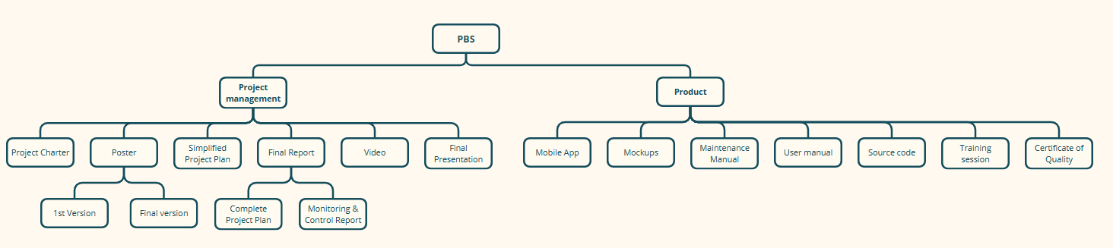

* 1. **Work Breakdown Structure**

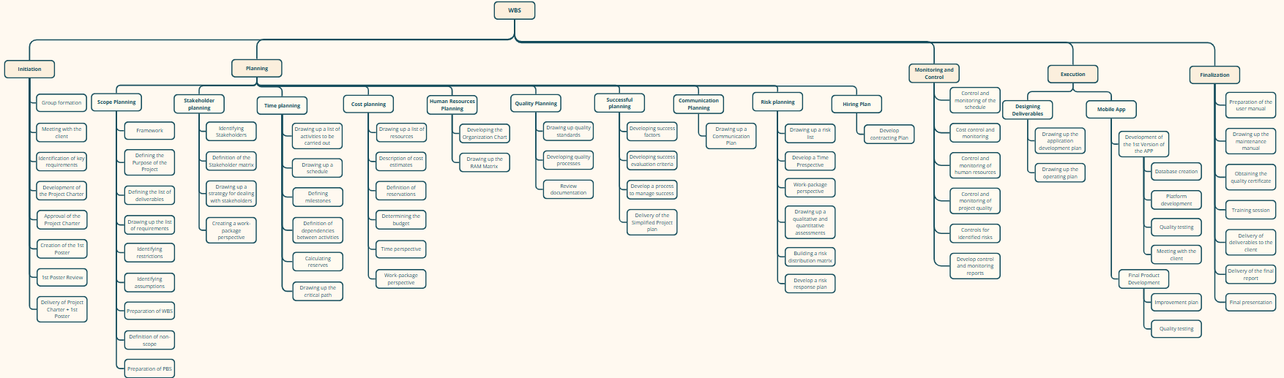

* 1. **R(e)BS**

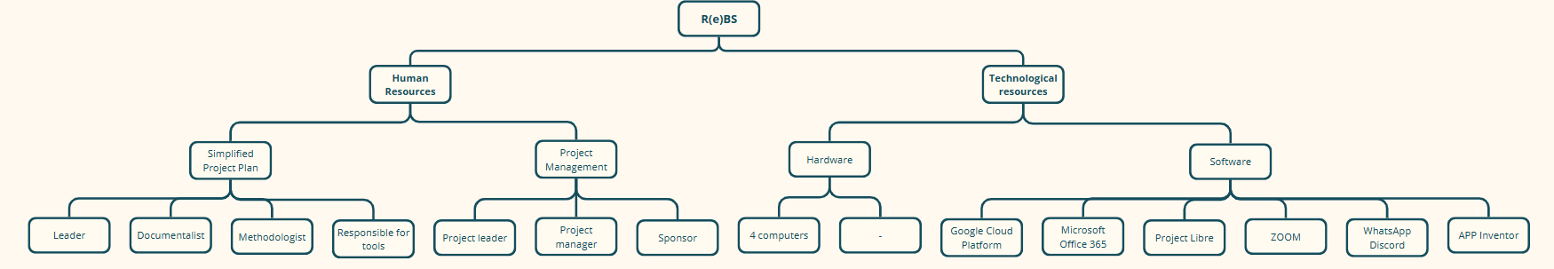

* 1. **OBS**

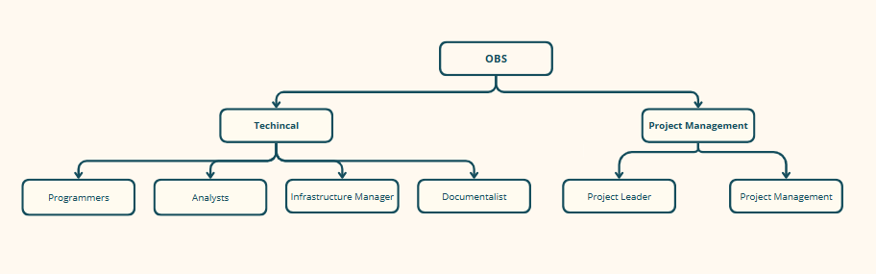

* 1. **R(i)BS**

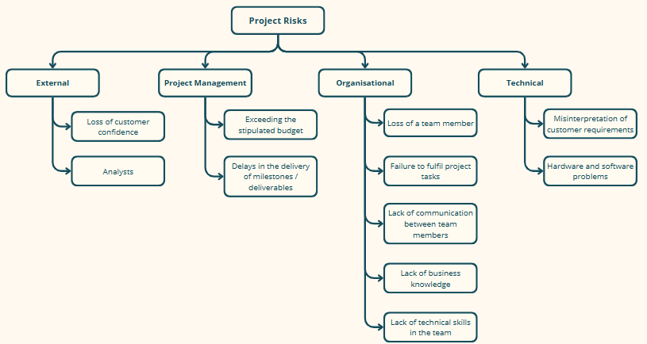

* 1. **Gantt Diagram**

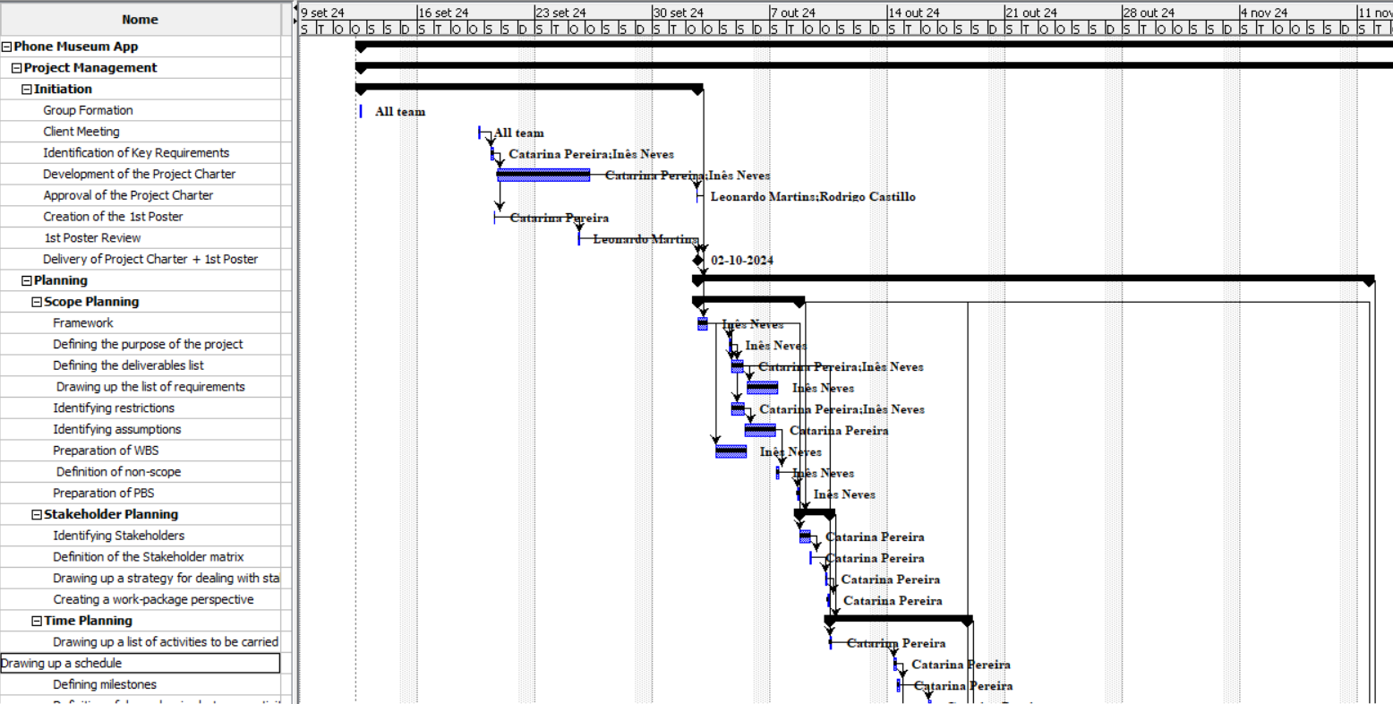

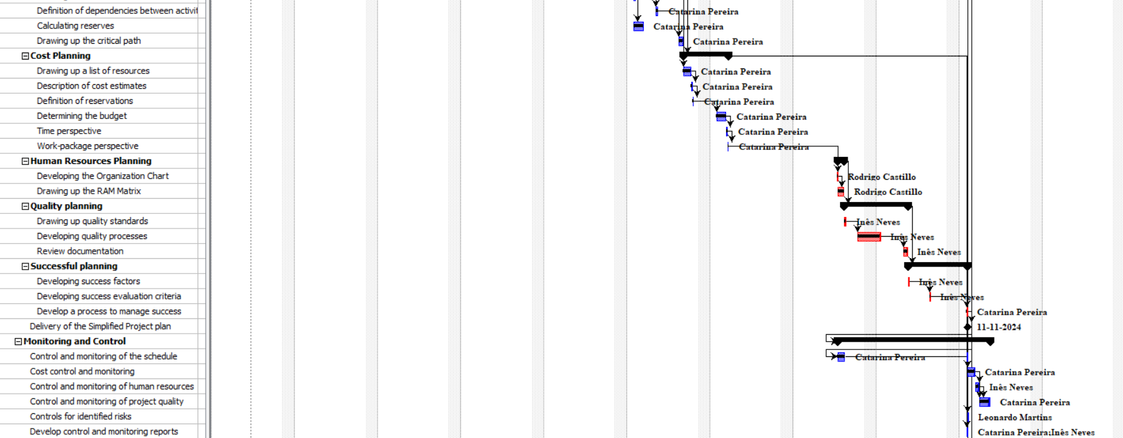

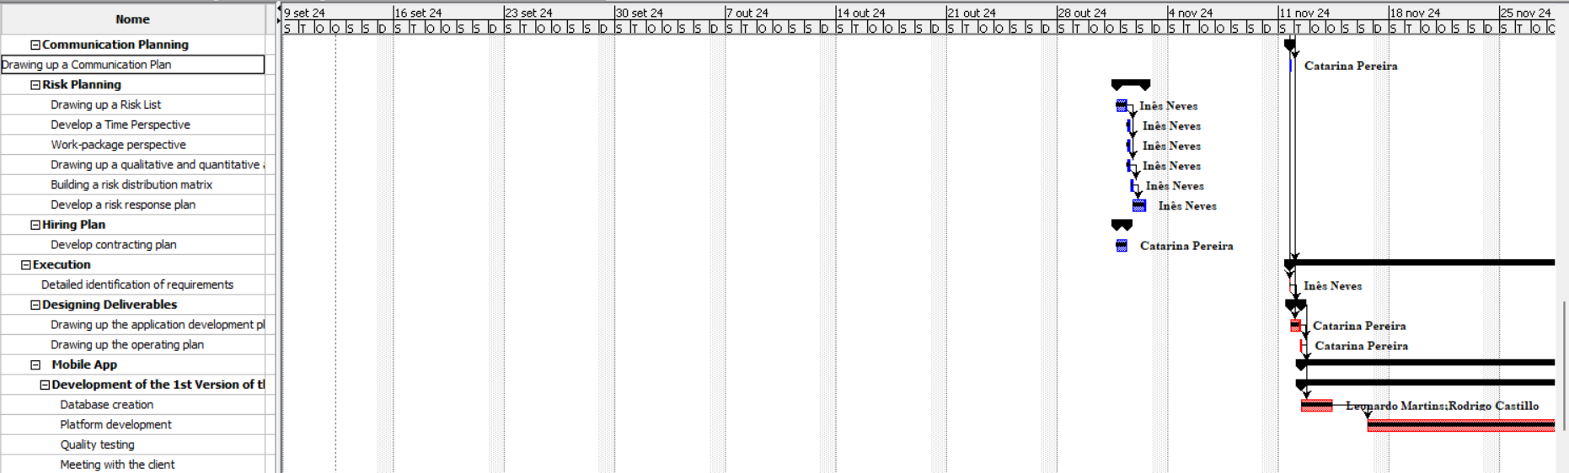

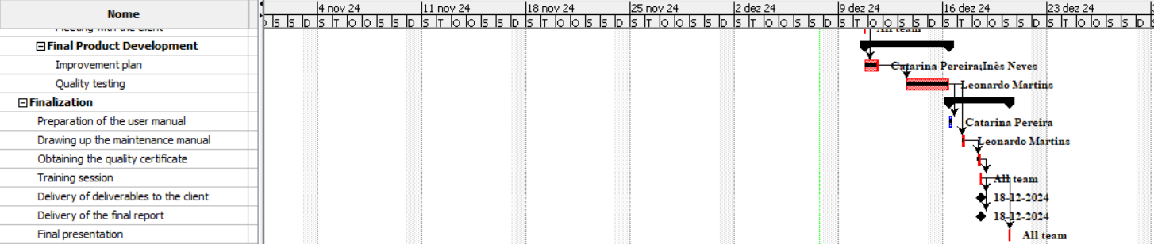



Declaration of Knowledge

The undersigned parties declare that they have read and fully understand the contents of this document. By signing it, they confirm that they are aware of all its terms, responsibilities and commitments, and assume the fulfillment of their duties as described in this document.

Date: ___________________

Team Leader

Sponsor